Data.sql on startup of application

* insert into account values(400123456,100.50);
* insert into account values(400234567,200);
* insert into account values(400345678,10000);
* insert into account values(400456789,64);
* insert into account values(400567890,32);

curl “localhost:8080”

Returns the list of amounts available. (The Id of the bank account is not shown as this is a property of the spring data @Id notation)

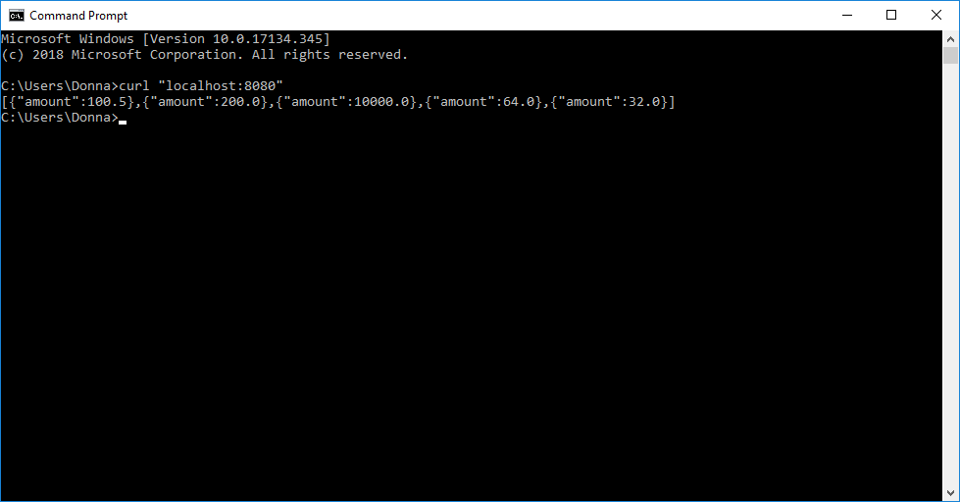

curl “localhost:8080/account/400123456”

Returns amount of bank account number 400123456.

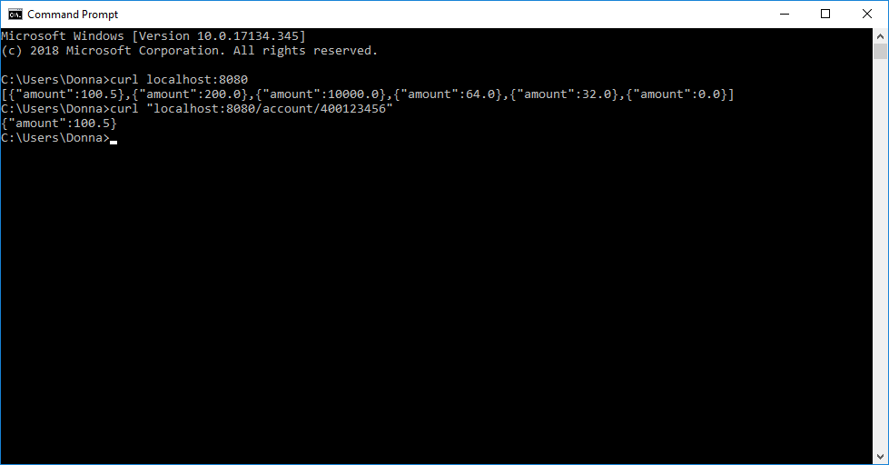

curl http://localhost:8080/add -d"id=400999999&amount=20.5"

Returns “Bank account added”.

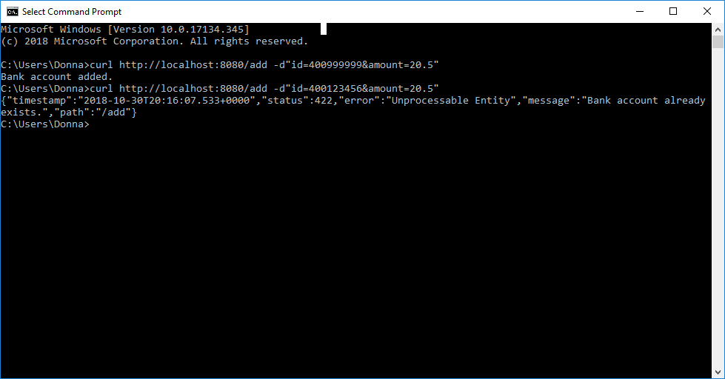

curl http://localhost:8080/add -d"id=400123456&amount=20.5"

Returns internal server error: bank account already exists.



Now note that **400123456** contains €**100**.**50** and **400234567** contains €**200**.We are going to transfer **€50.25** from the first account to the second account.

curl -X PUT localhost:8080/transfer -H "Content-Type:application/json" --data "{\"fromAccountId\":"400123456", \"toAccountId\":"400234567", \"amount\":"50.25"}"

Transfer completed.

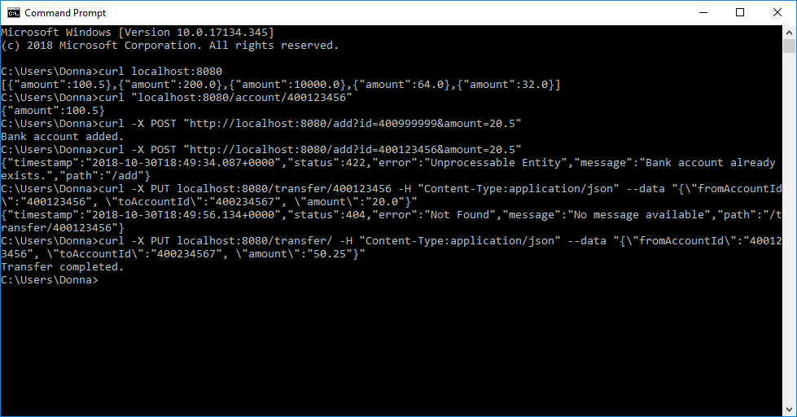

Now let’s validate the amounts by using curl <http://localhost:8080/>.

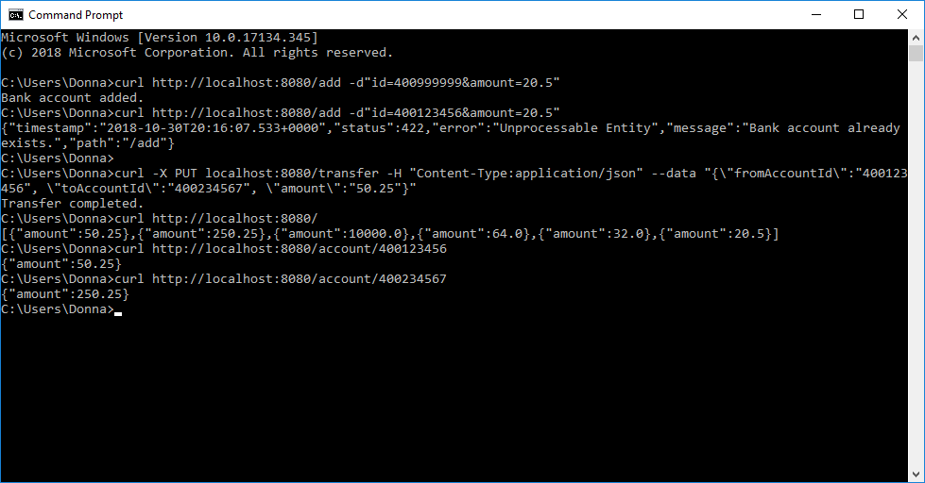

Now note that **400123456** contains €**50.25** and **400234567** contains €**250.25**.We are going to transfer **€100** from the first account to the second account.

curl -X PUT localhost:8080/transfer -H "Content-Type:application/json" --data "{\"fromAccountId\":"400123456", \"toAccountId\":"400234567", \"amount\":"100"}"

Returns error – failed to complete transaction.

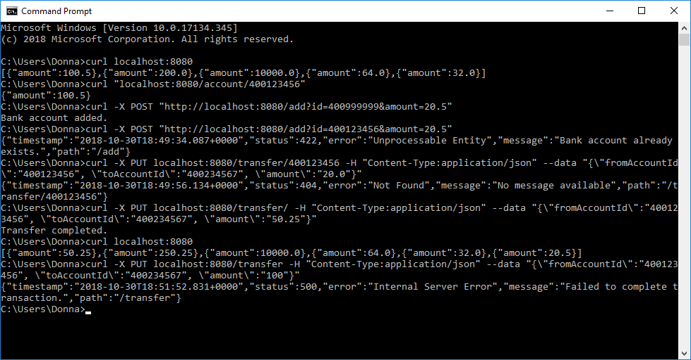

I also added a couple of exceptions:

if the transfer of amounts is occurring on the same account example:

curl -X PUT localhost:8080/transfer -H "Content-Type:application/json" --data "{\"fromAccountId\":"400123456", \"toAccountId\":"400123456", \"amount\":"50.25"}"

Returns error – failed to complete transaction.

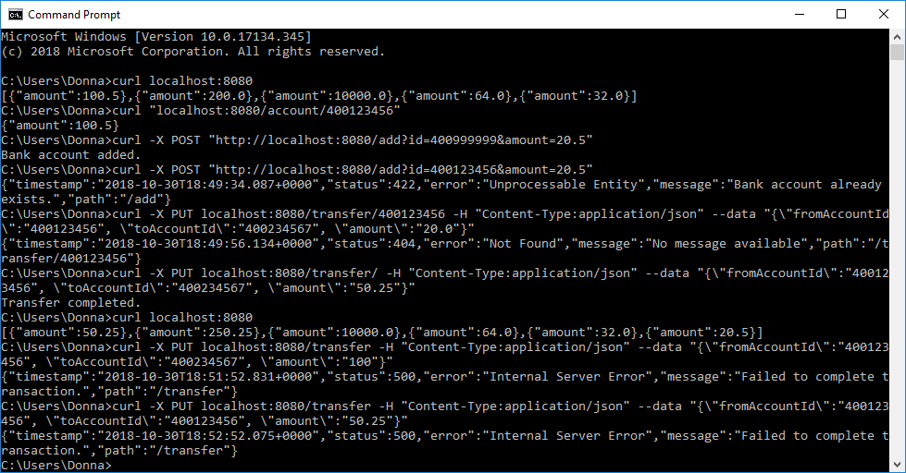

And the transfer must be greater than 0 example:

curl -X PUT localhost:8080/transfer -H "Content-Type:application/json" --data "{\"fromAccountId\":"400123456", \"toAccountId\":"400123456", \"amount\":"0"}"

Returns error – failed to complete transaction.

